💰 Personal Finance Manager (Python CLI Application)
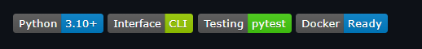

📌 Project Overview
Personal Finance Manager is a complete, modular, and production-ready Python command-line application designed to help users track expenses, manage budgets, generate reports, visualize spending trends, and maintain financial discipline.
This project demonstrates:
- Object-Oriented Programming (OOP)
- File handling & persistence (CSV & JSON)
- Data validation & error handling
- Reporting & visualization using matplotlib
- Unit testing using pytest
- Dockerized deployment
- Clean, scalable architecture

🎯 Key Features
🧾 Expense Management
- Add new expenses with validation
- Edit existing expense records
- Delete expenses with confirmation
- Persistent storage using CSV files
📊 Reports & Analytics
- Category-wise expense summary 📊
- Monthly expense reports 📅
- Total & average expense calculations 💰

📈 Visual Charts (Auto-Saved as PNG)
- Category-wise spending chart
- Monthly spending trend
- Budget vs Actual comparison
📁 Charts are saved automatically in:
reports/
💸 Budget Management
- Set category-wise monthly budgets
- Delete or update budgets
- Real-time alerts when:
  - Budget exceeds
  - Budget reaches warning threshold
🔔 Smart Alerts
- 🔴 Budget exceeded alerts
- 🟡 Budget nearing limit alerts
- Displayed immediately after adding expenses
🔍 Search Functionality
- Search by date
- Search by category
- Search by amount range
- Keyword-based search
🧪 Testing
- Unit tests for:
  - Validation logic
  - File handling
  - Budget calculations
- Automated testing using pytest
🐳 Docker Support
- Fully containerized application
- Reproducible environment
- One-command execution

🏗 Project Architecture
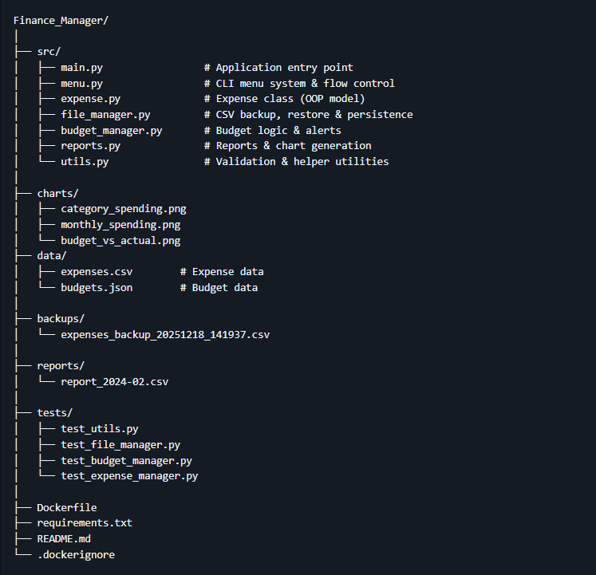

⚙️ Installation & Setup
🔹 Prerequisites
- Python 3.10+
- pip
- Git (optional)
- Docker (optional)

🔹 Local Setup
git clone <your-github-repo-url>
cd Finance_Manager
pip install -r requirements.txt
python main.py

🔹 Docker Setup (Recommended)
docker build -t finance-manager .
docker run -it finance-manager
✅ Ensures consistent execution across all environments.

🖥 Application Usage
🧭 Main Menu
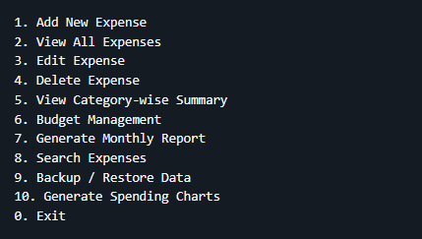

📊 Charts & Visualizations
Charts are generated using matplotlib and saved automatically.
Available Charts:
- 📊 Category Spending
- 📅 Monthly Spending Trend
- 💰 Budget vs Actual
📁 Location:
charts/
🖼 Screenshot Suggestions (Add to GitHub)
Added to below folder:
screenshots/
📸 Application Screenshots
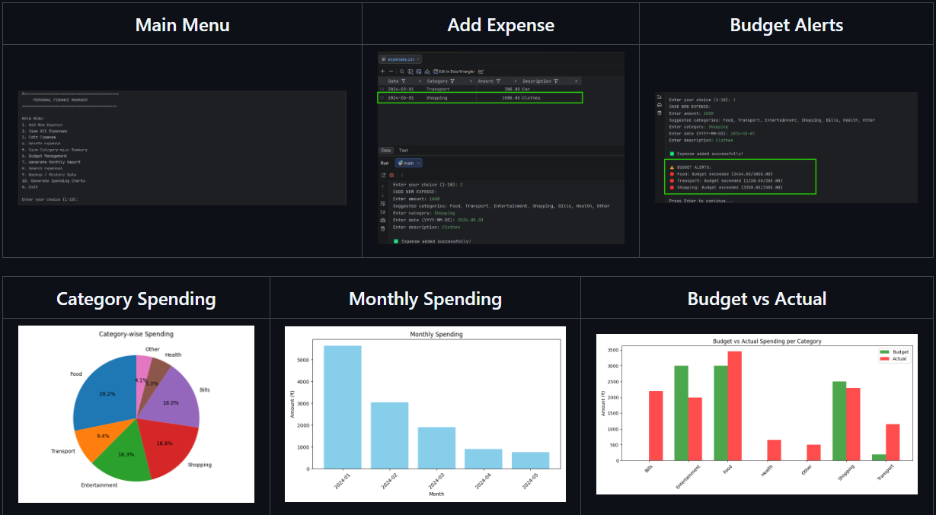

🧪 Testing
Run all unit tests:
pytest -v
✔ Covers:
- Input validation
- File persistence
- Budget logic

🔐 Error Handling & Validation
- Invalid inputs handled gracefully
- No crashes on user mistakes
- Clear error messages
- Safe file operations

🧠 Technical Highlights
- OOP design with clean separation of concerns
- Modular and extensible codebase
- CSV + JSON data persistence
- Industry-standard testing approach
- Dockerized for deployment

🚀 Future Enhancements
- GUI version (Tkinter / Streamlit)
- Cloud sync
- Multi-user support
- Database backend (SQLite/PostgreSQL)
- Data export (Excel / PDF)

⭐ Why This Project Matters
This project demonstrates real-world Python engineering skills, not just scripting:
- Architecture
- Testing
- Deployment
- Documentation
- Visualization
📌 This project was built as a complete end-to-end Python application to demonstrate real-world software engineering practices.

